**Lab #1**

**ELECTRICAL INSTRUMENTS**

**Part 1: DC Electrical Instruments**

This experiment will introduce you to the various instruments you will be using to measure electrical circuits throughout the course. Its purpose is to reveal instrument limitations and to create confidence in their application. Familiarity with the equipment and knowledge of its limitations will save a lot of frustration in future experiments. See Appendix 1A for further information.

**Ammeter Introduction**

To measure current flowing in a resistor, an ammeter is placed in series with the resistor, as shown in Fig.

1(b). Any meter connected to a circuit affects the circuit. This arises because any meter must "steal" power from the circuit to which it is connected to make a measurement. In the case of the Digital Multimeter (DMM) portion of the Hantek 2D42 the ammeter, in a subtler way, controls the processing of digits in the display.

A (0.05 )

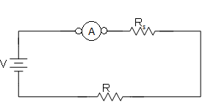

1 V 10  1 V



10 

1. (b)

(c)

Fig. 1. Measurement of current.

In the circuit of Fig. 1(a), we would expect (from Ohm’s law, I = V/R; see Appendix 1A) to have a current of 0.1 A flowing in the circuit. To measure this, an ammeter could be temporarily connected as shown in Fig. 1(b). An ideal ammeter would indicate 0.1 A. However, all real ammeters have some internal resistance (call it Rs). A good ammeter may have a resistance of only Rs=0.05 ohms. The total resistance limiting the flow of current in Fig. 1(b) is then 10.05 ohms and the current is then 1 V / 10.05

 = 0.0995 A, which the meter would faithfully read. Note that this current is lower than the 0.1 A expected without the ammeter. Thus, the introduction of the ammeter introduces an error. We can represent the ammeter by the circuit of Fig. 1(c), showing the internal resistance of the ammeter, RS. The

measured current will be I = V/(R+Rs), referring to Fig. 1(c). A good ammeter will have a low RS (ideally zero).

**Ammeter Setup**

Connect the circuit shown in Fig. 2 and 3.

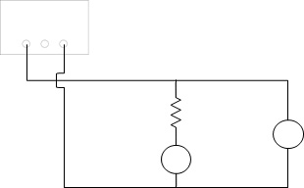POWER SUPPLY

+

R=30Ω +

V A

Apparatus:

Power supply (3V)

Hantek DMM (“A”)

Hantek DMM (“V”)

3x 10   resistor (R)

Fig. 2. Schematic of the DC current measurement setup.

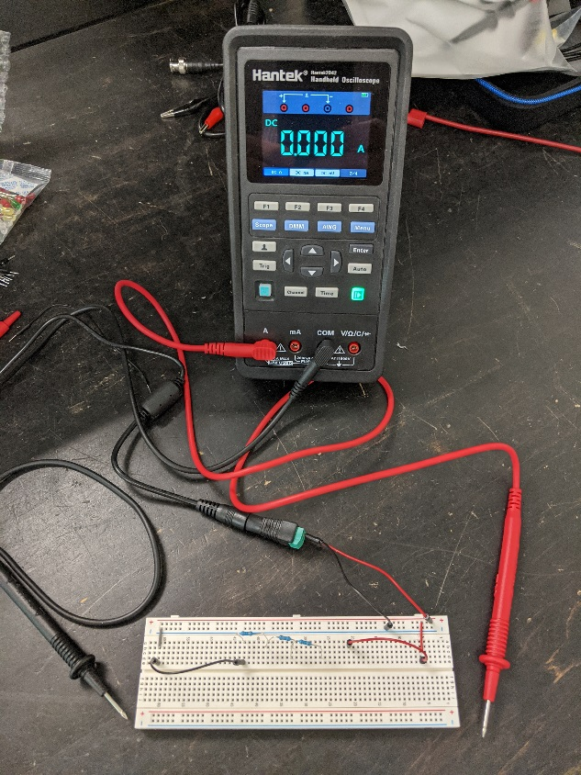

Fig. 3. Picture of the DC current measurement setup.

Using the DMM, measure the voltage of the power supply at its lowest setting, approximately 3V. (Note: The power supply has short-circuit protection). Re-cable the DMM to now measure current (200ma).

**Experimental Procedure**

Record the following data for your analysis:

DMM ammeter accuracy: with resolution of 100µA

DMM voltmeter accuracy: with resolution of 100µV

10 Ω resistor tolerance (see Appendix 1A): 5%

A DC current will be measured by the ammeter on two different ranges to see how the meter's presence affects the circuit operation.

Using the ammeter, record the current for each of the following two ammeter ranges: 10 A, and 200mA.

Current on 10 A scale: A

Current on 200mA scale: A

Determine the ammeter’s internal resistance from your calculations. For example, that on the 10A DC scale, a 10-amp reading would result in a voltage drop of 0.25V. The ammeter resistance in this case would be 0.25V/10A=0.025 . Note that resistance changes when the ammeter is switched to a new scale.

//insert work

Ammeter resistance on 10 A scale: **0.2 Ω**

Ammeter resistance on 200mA scale: **2.11 Ω**

**Answer the following questions in the blank space provided (show all your work and do full uncertainty analysis):**

What should the current be through the 30  resistor if it were connected directly across the 3 V power supply?

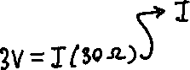

Show that the ammeter resistance accounts for the difference between your results and the current expected for the two ranges.

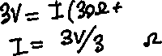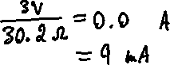

So, assuming voltage and resistance are ideal (V =3 V and R = 30 Ω) and adding in the resistance of the ammeter calculated previously, the new current calculated is lower than the current expected (100 mA). This shows that the internal ammeter resistance is the cause of the measured current being lower than expected. However, this value did not fall within uncertainty range of the measured values, A and A, so one can conclude that the internal resistance of the ammeter was not the only source of error causing current to drop. Another possible cause of error could be faulty equipment, or poor contact with the breadboard.

Compare the calculated resistance to the one from a dedicated ammeter/voltmeter -- what is the

minimum current/voltage that you feel confident in reporting as accurate in both cases.

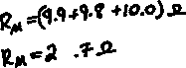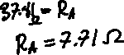

The previously calculated resistance is much smaller than the dedicated ammeter/voltmeter. This is unexpected since dedicated ammeters would tend to have lower resistance than a multimeter such as the Hantek. This implies that the Hantek has extraordinarily good resistance, which is likely not thecase in reality. Thus, it can be said that there was error in the Hantek values that may have been caused by poor contact with the breadboard, equipment error, or other errors related to the use of less sophisticated equipment. It was also noted that the voltage output of the power supply was measured by the Hantek to be unusually low.

The minimum current/voltage I would feel confident reporting as accurate would be 80 mA, since the dedicated ammeter/voltmeter is more reliable than the Hantek, and the value from the Hantek on this scale was very similar. I feel as though the smallest of the two values measured by the dedicated devices still reports accurate results which are close to what is expected, therefore 80 mA is accurate.

As for voltage, for both cases I would report a minimum of 3V as accurate, since the values measured by the ammeter are more accurate to what is expected, while the values calculated from the Hantek (2.748 V) were much lower than expected, which can be due to the low voltage measured.

**Voltmeter Introduction**

A voltmeter connected across any two points A and B will measure the potential energy an electron would lose in going from A to B, as shown in Fig. 4(a). To measure voltage from a voltage source, a voltmeter is placed across the terminals of the voltage source, as shown in Fig. 4(a). Similarly, to measure voltage across a resistor, a voltmeter is placed across (in parallel with) the resistor, as shown in Fig. 4(b).





A



2 V V

A

2 k

2 V V

B B

(a)

(b)

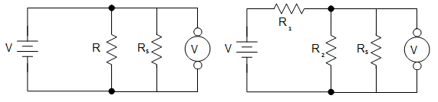

(c) (d)

Fig. 4. Measurement of voltage.

In Figure 4(c), the voltage across the resistor R is being measured with a non-ideal voltmeter. The voltmeter has an internal resistance RS which is in parallel with the resistor R during measurement. The presence of this internal resistance doesn’t affect the voltage measurement in this simple circuit because the ideal voltmeter is still in parallel with the voltage source V. If a second resistor is added to the circuit, this is no longer true. In Figure (d), there are resistors R1 and R2 in series with a voltage source V and a voltage measurement is being made across R2. Suppose the internal resistance of the voltmeter is Rs. The current drawn from the power supply is I=V/(R1+R2||Rs). The voltage measured across R2 is Vmeasured=V-IR1  
= V (1- R1/(R1+R2||Rs)). This equation tells us that the presence of the internal resistance of the multimeter makes the measured voltage less than the true voltage. Let’s assume V = 10V, R1= R2=10kΩ and Rs=100kΩ (note that for these values, Rs is not “infinite” with respect to the circuit resistances). The ideal voltage across R2 would be 5V since R1 and R2 form a voltage divider with equal resistances. The measured voltage is in fact 4.76V (can be confirmed via the equation above); therefore, the voltmeter’s internal resistance introduces an error. An ideal voltmeter should have infinite RS so that R2||Rs ≈ R2 i.e., no current flows through the internal resistance of the voltmeter since its resistance is much larger than the component it’s connected across.

**The resistance of an ideal voltmeter is infinite, and the resistance of an ideal ammeter is zero.**

**Voltmeter Setup**

The DMM portion of the Hantek 2D42 will be used to measure voltages in two simple DC circuits to see how the meter's presence affects the circuit operation.

Set up the circuit in Fig. 5(a). Connect the voltmeter last. Set the power supply to 3.0 V.

Apparatus: Power supply

Hantek DMM (V)

2x l kΩ resistors

2x l00 kΩ resistors



Power Supply Power Supply

+ +

1KΩ 100KΩ

V V

1KΩ 100KΩ

Fig. 5. Schematic of the DC voltage measurement setup.

**Experimental Procedure**

Record the following data for your analysis:

Digital voltmeter accuracy: ** (0.8% of reading + 5*least significant digits) (Resolution: 1 mV)**

1 kΩ resistor tolerance (see Appendix 1A): **1%**

100 kΩ resistor tolerance (see Appendix 1A): **1%**

Use the digital multimeter to measure the voltage across one resistor, then the other, in the circuit of Fig.

5(a).

Voltage across the first l k resistor: **1.563  0.02 V**

Voltage across the second l k resistor: **1.562  0.02 V**

Replace the l k resistors with 100 k resistors as in Fig. 5(b). Recheck the power supply voltage to see that it has not changed. Measure the voltages again across the individual resistors.

Voltage across the first l00 k resistor: **1.570  0.02 V**

Voltage across the second l00 k resistor: **1.578  0.02 V**

The digital voltmeter has a fixed 10M internal resistance on all scales.

**Answer the following questions in the blank space provided (show all your work and do full uncertainty analysis):**

Calculate the voltage that should appear across each resistor in Figure 5(a) and Figure 5 (b) with no voltmeter in the circuit.



Account for by the inaccuracy of the voltmeters and tolerance of the components? (Calculate the errors).

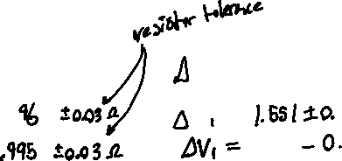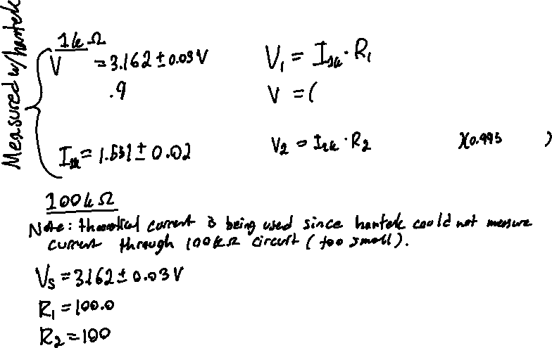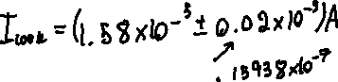

If equipment errors cannot account for the disparity between the calculated voltages and measured voltages, show that the voltmeter resistance can.

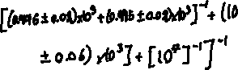

When accounting for the resistance of the Hantek

Compare the calculated resistance to the one from a dedicated ammeter/voltmeter -- what is the minimum current/voltage that you feel confident in reporting as accurate in both cases.

**Part 2: AC Electrical Instruments**

Read Appendix 1B for further information.

This experiment continues with the introduction of general electrical laboratory measuring equipment, particularly instruments involved with generating and measuring alternating currents.

**Function Generator Introduction (Arbitrary Waveform Generator, AWG)**



An idealized source of alternating voltage is designated by a symbol and would be capable of supplying an infinite current to a short circuit load. Such an item does not exist of course, but the concept of ideal sources is useful when breaking circuits down to their electrical essence.

**A function generator's less than ideal characteristics can be simulated by including a resistor in series with an ideal AC voltage source and its value has been standardized at 50** **.** Note that such circuitry may not exist inside the box, but electrically, looking into the output jack you could not tell the difference. The symbol of the voltage source is often used in circuit diagrams, with the series resistance only implied.

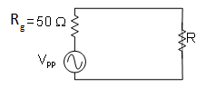Vpp R

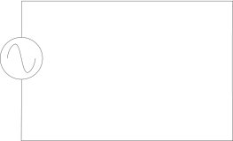

(a) (b) Fig. 6. Schematic of function generator.

Suppose the peak-to-peak voltage Vpp of the function generator in Fig. 6(a) is 1 V and R = 1 k (see Appendix 1B for an explanation of peak-to-peak). Similar to the previous analysis for ammeters, we would expect the voltage drop across the resistor to be 1 V peak-to-peak (p-p) and the current to be Ipp = Vpp/R = 1 V / 1 k = 1 mA p-p. However, function generators have an internal resistance standardized to Rs = 50  as shown in Fig. 6(b). Hence, Ipp = Vpp/(R+Rs) = 1 V / (1 k + 50 ) ≈ 1 mA p-p. In this case, the function generator has a negligible effect on the current and hence the voltage drop across R. Now suppose that R = 50 . In this case, it is easy to show that the effect of the function generator is to reduce the current to 0.5 mA p-p and the voltage across the resistor R to 0.5 V, half of what is expected. Hence, the function generator can introduce errors as the load resistance approaches 50  and less.

**Experimental Setup**

This experiment demonstrates the effect of loading upon the output of a function generator. In the process, its internal resistance will be determined.

Set up the circuit shown in Fig. 7 and 8.

Apparatus: 1 function generator, Hantek AWG

1 oscilloscope, Hantek Scope

Various resistors in parallel and/or series

coaxial connection cable

scope probe

Rg BNC BNC

connector

Vg

RL

connector

FUNCTION GENERATOR



OSCILLOSCOPE

Fig. 7. Schematic of function generator setup.

PHOTO PENDING

Fig. 8. Picture of function generator setup.

In Fig. 7, the function generator is modeled as an ideal AC voltage source (vg) in series with an internal resistance (Rg). Note that the amplitude of vg can be adjusted by a knob on the front panel of the function generator. During the procedures to follow, vg must remain at a constant amplitude. Set the amplitude to be large enough to easily measure the signal on the oscilloscope (something around 1Vpp should be fine) and after doing so**, do not adjust the function generator’s amplitude control any more.**

Set the function generator for a sinewave, with a frequency of 1 kHz.

**Experimental Procedure**

Record the following data for your analysis:

Oscilloscope accuracy: Resistor accuracy: the smallest division on the scale you’re measuring on

Combine various resistor in a series and/or parallel circuit to give you 20 values between 1Ω and 50Ω. Be cautious not to short (0Ω) the AWG. These values can be determined by you. Also take readings at 100Ω, 500Ω, and 1KΩ. Observe and record the AC voltage on the Scope. You should see that at high resistance, the amplitude does not change. At lower resistance the amplitude decreases. Record the values of resistance you create and the corresponding amplitude. You will use this data to calculate Vg and Rg.

**Include the measurement uncertainty in your data points.**

|  |  |
| --- | --- |
| Resistance (Ω) | Amplitude (VPP) |
|  |  |
|  |  |
|  |  |
|  |  |
|  |  |
|  |  |
|  |  |
|  |  |
|  |  |
|  |  |
|  |  |
|  |  |
|  |  |
|  |  |
|  |  |
|  |  |
|  |  |
|  |  |
|  |  |
|  |  |
|  |  |
|  |  |
|  |  |

Table 1

**Answer the following questions in the blank space provided (show all your work and do full uncertainty analysis):**

Derive a mathematical relationship between Vg, Rg and the voltage V measured across a load resistance RL for the circuit in Figure 7. Neglect the effect of the internal resistance of the oscilloscope since its internal resistance is 1 MΩ when using 1x mode on the scope probe, which is much larger than the circuit resistances.

Make a plot of amplitude vs. resistance using your data in table 1 and attach it to this report. Use the plot to solve for the two unknowns – the amplitude of the AC voltage source Vg and the internal resistance Rg. Record these values below. Put error bars in your plot.

Function generator’s voltage amplitude (Vg - peak to peak):    V

Function generator’s internal resistance (Rg):    Ω

Compare the function generator’s output impedance (Rg) with the standardized value of 50Ω; do they agree?

All electrical circuits have impedance across their inputs and outputs which are called the input and output impedances. Typically, circuits will be designed to have high input impedance and low output impedance; this is so that they can be connected with minimal voltage drop at the output stage of one circuit when it’s connected to the input stage of another. Why does having high input impedance and low output impedance make this happen?

If you connected the function generator’s output to the input of an arbitrary circuit, what should be the range of input impedances (resistances) of that circuit to minimize the amplitude drop at the input? Explain your reasoning. Can you think of any reasons you would want to match the output impedance of the function generator to the input impedance of the circuit (i.e., make the input impedance 50Ω)?

Explain your reasoning. (Hint: think about transferred power)

Reflect on the key components of this lab and its applicability.

**More Oscilloscope (Optional)**

Here are some suggestions to practice on the oscilloscope. Your demonstrator can help in explaining things that are difficult to put into this guide.

Connect the output of the AWG to one of the oscilloscope channels.

1. Set the function generator to several different frequencies between 1 Hz and 100 kHz. Use the oscilloscope horizontal scale to measure the period.

2. Trigger the scope with each waveform. Try triggering manually. Trigger in various modes (auto, normal, single). Why does acquisition sometimes stop?

3. Try changing the trigger slope and note the effect.

4. The AWG has a "Offset" which adds a DC voltage to the output along with the AC waveform. Adjust this control while looking at the waveform. Observe the display under various coupling conditions (DC, AC, GND) while varying the function generator's DC offset control.

5. The AWG has a “Duty” function. Adjust this feature while looking at the waveform.

6. The AWG has a maximum deviation of 2.5V. Vary both the Amplitude and Offset and not how they interact.

7. The Scope has a “Cursor” function. Turn this on and explore both the Volt and Time options. Use the cursor to identify measurement points and note the delta values.

8. The scope has a “Measurement” function. Turn this on and play with the options available. Note the difference where there is a discrepancy between the auto value and your manual read value. This option is different between Hanteks depending on the revision of firmware installed.

9. There are 3 ways to collect data from the Scope screen, manually taking the reading, via the Cursor function, and via the Measurement function. Discuss and compare the errors and accuracies of these 3 methods.

**Appendix 1A: DC Current and Voltage Measurement**

**Direct Current (DC)**

Direct current (DC) is used to describe current which is essentially a constant value and flows in only one direction (referred to as polarity). The term DC refers to both current and voltage. A DC voltage is a voltage having only one polarity.

**Resistance**

Resistance is the term used to describe the ability of a medium to resist the transfer of charge through it. The unit of measurement for resistance is the ohm (denoted ).

**Ohm’s Law**

The current in a circuit varies directly as the voltage applied to the circuit and inversely as the resistance of the circuit.

I = V/R

This gives a value to the resistance: 1 ohm = 1 volt/ampere

**Resistance and Resistors**

Resistance is a quantity that can be manufactured. Resistors are made and are available in many different values of resistance so that control of current from a source of voltage can be obtained (I = V/R). The manufactured resistors use a color code rather than having their resistance values printed on them. This colour code is universal and is as follows:

**COLOUR FIRST SECOND MULTIPLIER TOLERANCE**

|  |  |  |  |  |
| --- | --- | --- | --- | --- |
| BLACK | . . . . . | 0 | 1 |  |
| BROWN | 1 | 1 | 10 |
| RED | 2 | 2 | 100 |
| ORANGE | 3 | 3 | 1,000 |
| YELLOW | 4 | 4 | 10,000 |
| GREEN | 5 | 5 | 100,000 |
| BLUE | 6 | 6 | 1,000,000 |
| VIOLET | 7 | 7 | 10,000,000 |
| GREY | 8 | 8 |  |
| WHITE | 9 | 9 |  |
| GOLD |  |  | 0.1 | ±5% |
| SILVER |  |  | 0.01 | ±10% |
| BLANK |  |  |  | ±20% |

Examples:

0.22  ± 5% RED, RED, SILVER, GOLD

39  ± 10% ORANGE, WHITE, BLACK, SILVER

120  ± 20% BROWN, RED, BROWN

470 000  ± 5% YELLOW, VIOLET, YELLOW, GOLD

The multipliers of the resistors give an indication of the range of values that are covered in electrical studies. In order to make discussions less cumbersome a series of prefixes have been adopted to indicate multipliers. Terms **in bold type** are the ones most often used.

**Prefix Multiplier Symbol**

tera 1012 T **giga 109 G mega 106 M kilo 103 k** hecto 102 h deka 10 da deci 10-1 d centi 10-2 cm **milli 10-3 m micro 10-6**  **nano 10-9 n pico 10-12 p** femto 10-15 f atto 10-18 a

Examples:

1,000,000 ohms = 1 M = one megaohm

0.001 amperes = 1 mA = one milliampere

0.000,000,000,001 coulombs = 1 pC = 1 picocoulomb

**Resistors, Volts and Amperes in Circuits**

The resistor in circuit diagrams is indicated by the symbol and the term ohm is usually replaced by the Greek letter capital omega, . There are some basic relationships between resistors in a circuit and these relationships can be used to determine resistances, currents and voltages.

For resistors in series, as shown in Fig. 1 below, the current IT is the same in all of the resistors. The voltages across the resistors add up to the total voltage from the power supply, VT. Hence, the total resistance can be calculated as follows:

VT = ITRT = V1 + V2 + … + Vn = ITR1 + ITR2 + … ITRn

Therefore, RT = R1 + R2 + … + Rn

An equivalent circuit, shown on the right side of Fig. 1 can be drawn to replace the circuit on the left.

R 1 R 2

+

V T

+

R 3 V T RT

- I T - I T

R n R 4

RT = R1 + R2 + R3 + R4 + … Rn

Fig. 1. Resistors in series.

For resistors in parallel, as in Fig. 2 below, the voltage across each resistor is the same. The current through each resistor is equal to the applied voltage divided by the resistance, e.g., I1 = VT/R1. The sum of the individual currents equals the applied voltage divided by the total resistance of the circuit. Hence,

IT = I1 + I2 + … + In

VT/RT = VT/R1 + VT/R2 + … + VT/Rn

1/RT = 1/R1 + 1/R2 + … 1/Rn

For two resistors in parallel,

*R*  *R*

*R*  1 2

*T R*  *R*

1 2

+

V R1



-

R2

I1 I2

… Rn



In

1/RT = 1/R1 + 1/R2 +1/R3 + 1/R4 +… 1/Rn

Fig. 2. Resistors in parallel

**Digital Meters (DMM)**

Digital meters are now used almost exclusively in industry. Electromechanical meters were used in the 2A04 lab however they have been replaced just like calculators replaced slide rules. In a digital meter, the mechanical needle is replaced with a digital display. This is a major convenience and saves a lot of frustration for the beginner. Digital meters also remove human reading error. Analog meter had to be read directly overhead or a parallax reading error would be introduced.

**DC Power Supplies**

You will be using a variety of DC power supplies in these labs, so a particular one will not be described in detail. A perfect DC power source would have a constant output voltage that would not change as the load current changes.

A "regulated power supply" is one that controls its output voltage by electronic means. When operated within its power limitations, the voltage will remain constant despite changes in load current. A convenient feature found on most regulated supplies is called "current limiting". It will shut the voltage down when too much current flows into the load, protecting both the regulating electronics and the load itself. Some supplies have adjustable current limits on the front panel.

**Appendix 1B: Measurement of Alternating Current and Voltage**

**Waveforms**

Alternating current is defined as a flow of electricity which reaches a maximum in one direction, decreases to zero, then reverses itself and reaches a maximum in the opposite direction. This cycle is repeated continuously. The term AC refers to both current and voltage.

The main point of understanding alternating current is that we are now dealing with a time dependent variable and that any measurements made must take into consideration the point in time at which the measurement was made. The simplest form of alternating current is the sinewave. The basic method by which a sinewave is produced is by rotating a conductor in a magnetic field. This is the principle used to create electric power today.

90 VP



180

0    

   

  

270

Fig. 4. The sinewave and its properties.

The equation for finding either the instantaneous voltage or current is related to the maximum level by:

v = vpsin(t)

v = instantaneous voltage vp = maximum voltage

⬥ = angular velocity of the rotating vector in radians per second

t = the time at which the measurement was taken with respect to the starting time of the cycle.

The time it takes the sinewave to repeat is called the period or cycle and the number of periods in a second is called the frequency. Frequency is the number of cycles per second. The term cycles per second has been replaced by the name Hertz (Hz).

1 Hertz = 1 cycle per second

The sinewave is the basic waveform in AC circuits. There are, of course, many other waveforms which can be created: square waves, triangular waves, sawtooths, and a host of others. They all, however, can be shown to be made up of a fundamental sinewave and a number of harmonics (multiples of the fundamental's frequency) whose algebraic sum at a particular instant in time will give the resultant waveform's instantaneous amplitude. Hence, the sinewave is the most important waveform.

Pulsating DC is the term given to electrical quantities whose amplitude varies with time; however, at no time does it cross zero and reverse polarity**.**

**Function Generator (AWG)**

Very often it is necessary to analyze the AC characteristics of an electric circuit. For this purpose, the function generator / oscilloscope combination is very versatile and will be used often in these labs.

The term "function generator" generally describes an instrument that provides an alternating current ranging from subaudio frequencies to a few megahertz, in either sine, square or triangle waveforms. The amplitude of the output voltage is continuously variable from a few millivolts to about twenty volts peak to peak.

In addition, there may be a number of convenient controls, a few of which are useful for our purposes. The "DC Offset" or "Waveform Offset" is a control which adds a DC voltage to the alternating output. This control can add a voltage ranging from –10 V to +10 V DC and affects neither frequency nor amplitude of the AC waveform. A jack you may find useful is the "Pulse Out" or "1 volt P-P". The square wave output from this jack is the same frequency as the function generator output, but is fixed in amplitude. It is often used to trigger the oscilloscope via its external trigger.

**Peak-to-Peak**

The peak to peak measurement is made between the two extreme excursions of the waveform. i.e. if one extreme occurs at **+**A**,** the other occurs at -A, then we say the amplitude is A and the peak-to-peak (p-p) amplitude is 2A.

**Root-Mean-Square**

The rms value of a periodic function for period T is derived from its mathematical expression, f(t):

For a sinewave

The rms amplitude of a waveform will always be less than, or equal to its peak amplitude. This rather complex procedure finds utility in comparing AC power to DC power: one-watt rms would dissipate the same heat as one watt DC.

The rms value is used because the power dissipated in a circuit element is directly proportional to the square of the current in DC, i.e.

P = I2R.

**Power in AC Circuits**

Peak Power

Ppk = Vpk x Ipk

Effective Power = Root Mean Square Power (rms) Prms = Vrms x Irms

**Oscilloscope (Scope)**

The instrument used to display waveforms is called the oscilloscope or scope. The scope originally used an electron beam to “draw” the waveform on a screen much like the way old CRT (cathode ray tube) televisions work. Most modern scopes use a flat screen display to visualize this information combining it with measurement features not available on older analog scopes. The horizontal and vertical scales on the scope are controlled by the multifunction softkeys on the device. The scope is the most versatile piece of equipment in the laboratory. Used properly, it can tell the experimenter a great deal about the electrical phenomenon being studied. The Hantek 2D42 is a versatile multifunction device combining the features of an oscilloscope, function generator, and digital multimeter into one handheld device. You can find a complete description of its controls and specifications by downloading HANTEK 2D42 Manual.pdf from Avenue to Learn.

The calibrated amplifier (labeled “volts/div") rotary switch setting determines the vertical amplitude of

the displayed swing. Thus, the vertical axis of the display can be thought of in terms of volts.

The horizontal axis is one of time (sec/div). Samples are displayed sequentially from left to right across the whole display area. Sample rate can be varied with a rotary switch ("sec/div") from very slow (5 sec/div) to very fast (5 ns/div).

The graticule on the screen has 10 cm marked off over the oscilloscope display with the calibration set as sec/cm. The period of a 2 kHz sinewave could be measured in the following way.

- Set the SEC/DIV switch to 50 sec.

- Use the horizontal **POSITION** control (to set the beginning of the trace on the left-most graticule mark.

- Count off the number of centimeters for one cycle of the sinewave. This should be 10.0 cm.

- The sinewave period is 10 cm x 50 sec/cm = 500 sec.

The vertical and horizontal scales, controlled by the "volts/div" and "time/div" rotary switches respectively, are the two most important systems in the oscilloscope. There are other controls and switches which may be classified as convenient additions that simplify measurements which would otherwise be difficult.

The oscilloscopes used in this laboratory have two complete vertical systems, each having its own input jack. The horizontal system is common to both and sweeps both traces across the screen at the same rate. Thus, with two signals being displayed at once, you may measure their relative amplitudes or time relationships.

**Triggering**

**(Trig)**

The oscilloscope triggering system, in conjunction with the horizontal sweep system, is a convenience control that enables the user to display stable AC signals.

Let us look at how an untriggered horizontal sweep would probably display a sinewave (Figure 10).

sweep sweep sweep sweep sweep sweep

#1 #2 #3 #4 #5 #6

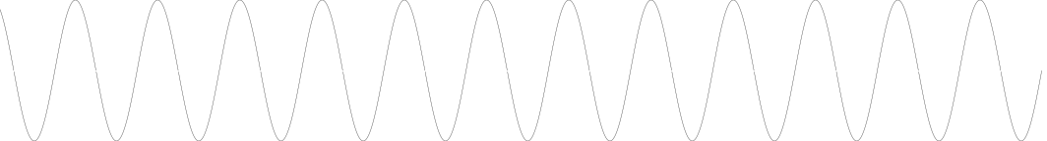

Fig. 5. Untriggered horizontal sweep. Note that the sweep time is independent of the incoming sinewave, and that a new trace is initiated immediately on completion of the old.

Combining these sweeps as they would appear on the oscilloscope face, you get this jumble (Figure A6):

5 4 3 2 1 6

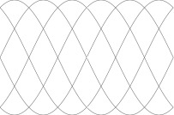

2 1 6 5 4 3

Fig 6. Oscilloscope traces with untriggered horizontal sweep - an accumulation of Fig. 5 sweeps.

You can see that the problem arises because the horizontal sweep does not begin at the same point on the waveform for every sweep**.**

The triggering system works by holding the horizontal sweep at the left side of the screen until two criteria are met, then the sweep is "triggered" and starts its normal sweep across the screen.

The two conditions that must be met are that the waveform must reach a specific voltage level, and it

must be approached from the proper direction. If they are not both met, the horizontal sweep will never be triggered and the screen will be blank.

sweep sweep sweep sweep sweep sweep

#1 #2 #3 #4 #5 #6

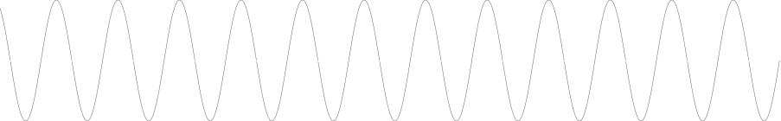

(a) (b) (c)

(b)

(a)

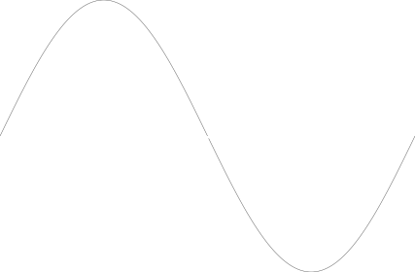

Fig. 7. A sinewave triggered to sweep on positive going voltage of 0 V. The horizontal trace is at the left of the screen at (a) and sweeps across to the right (b). Note that at (c) the 0 volt condition is met, but it has been approached from the positive to negative direction, so a new sweep is not triggered here.

The horizontal sweep system on the oscilloscopes used in this laboratory can be triggered from four sources - either of the two y deflection channels, externally, or from the 60 Hz AC line. Triggering can occur on either positive or negative going slope at a voltage level optionally set by the user ("level" control) , or can be generated automatically ("set level to 50%").

**Using D'Arsonval Movement for AC Measurements**

The mechanical inertia of the needle-coil assembly of the DC measuring D'arsonval movement means that the needle cannot follow an AC signal whose frequency is greater than a few cycles per second. Above this frequency, the meter will read zero, since the current tending to pull the needle upscale is exactly equal to the current pulling it downscale on each half cycle of the sinewave.

To measure AC signals then, the waveform is rectified, meaning it is made unipolar, by using an electronic device that only allows current to flow in one direction. The average value of the rectified AC (now pulsating DC value) is 0.637 times the peak value for a sinewave.

The effective value, or rms is a more useful measurement than the average, and the scale of most meters is modified to read rms - for sinewaves only. Other waveshapes, whose ratio of average to rms is different, will read erroneously. Some digital meters display true rms for those non-sinusoidal waveshapes, as well as sinewaves.

(a) common waveform relationships (b) rectified waveform

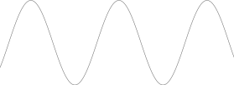

Vrms Vp

Vav

VavVrms Vp



Vrms Vp

Vav

VavVrms Vp

Vrms Vp

Vav

VavVrms Vp

Fig. 8. Rectification.